1. Odd String Difference

CODE:

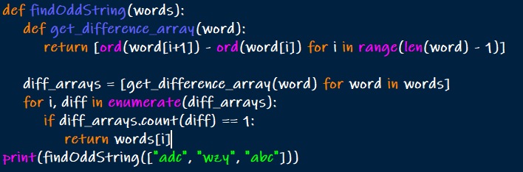

OUTPUT:



1. Words Within Two Edits of Dictionary

CODE:

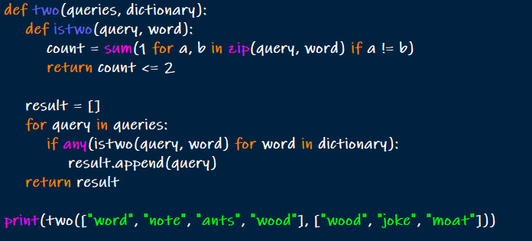

OUTPUT:



1. Next Greater Element IV

CODE:

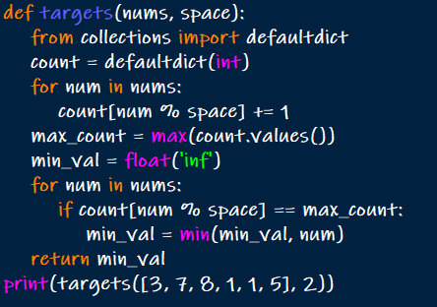

OUTPUT:



1. Minimum Addition to Make Integer Beautiful

CODE:

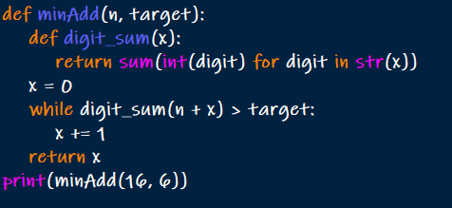

OUTPUT:



1. Sort Array by Moving Items to Empty Space

CODE:

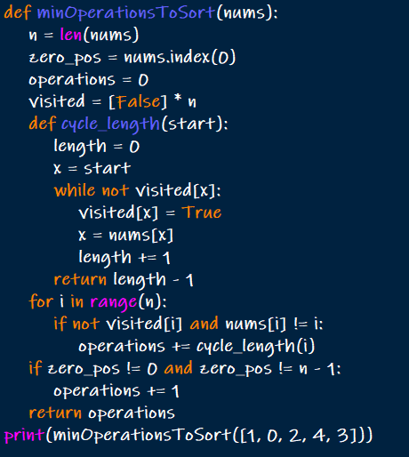

OUTPUT:



1. Apply Operations to an Array

CODE:

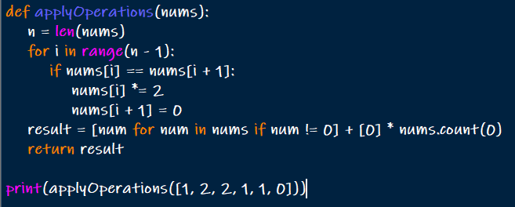

OUTPUT:



ANALYTICAL PROBLEMS

